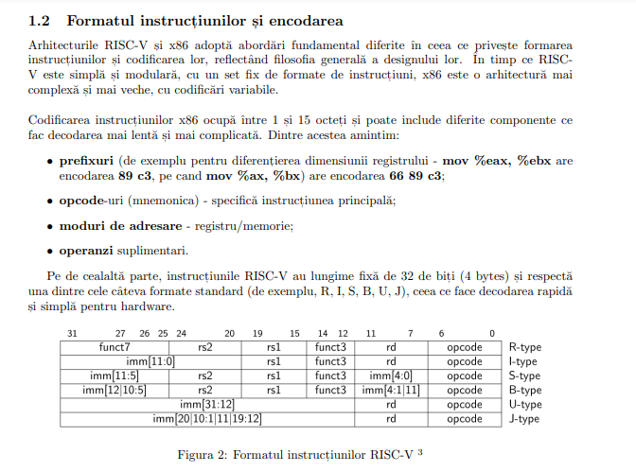

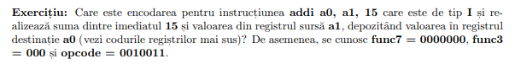

OPCODE -> 0010011

RD (a0) -> 10 = 1010

FUNCT3 -> 000

RS1 (a1) -> 11 = 1011

IMM = 15 =

FUNCT7 -> 00000000

